Watch this video for an Overview of the PD Toolkit and ideas for how you can use it in under 15 minutes!

Toolkit for Strengthening Quality:
A Resource Roundup
for Birth-to-Five Leaders
(first released to VQB5 Spring 2022)

Developed collaboratively by:
UVA-CASTL Advancing Effective Interactions & Instruction,
The Virginia Early Childhood Foundation,
Virginia Department of Education Training and Technical Assistance Network,
Infant and Toddler Specialist Network,
and the Virginia Department of Education
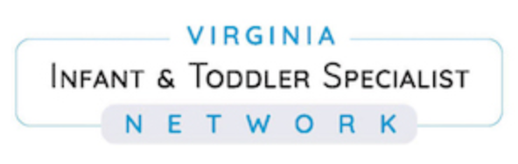
Toolkit for Strengthening Quality:
A Resource Roundup for Birth-to-Five Leaders

WHO: This toolkit was designed for program leaders and Quality Improvement providers who support program leaders and/or teachers in Virginia’s Birth-to-Five programs.

WHAT: The toolkit provides leaders with key resources for strengthening quality, including implementing CLASS® and planning professional development (PD) focused on interactions, curriculum, inclusive practices, and supporting each and every learner.

WHY: The purpose of the toolkit is to provide leaders with useful resources that will help them implement CLASS® and plan data-driven, individualized PD that strengthens quality.

HOW: Multiple stakeholders across Virginia sourced and developed a list of ready-to-use resources to meet a variety of needs related to strengthening quality. We’ve organized these resources into sections based on specific needs that the VQB5 community has shared.

Instructions for Leaders: Browse the sections below, select 1 section as your priority, then identify 1 or more resource(s) in that section that best meets the needs you have identified for yourself (as a leader), your teachers, or leaders you support.

Guiding Question to Consider: What is your most pressing question about how to grow quality in your program (or the programs you support)?

Section 1) How do I understand or help my teachers understand the CLASS® tool(s)?

Section 2) How do I self-assess strengths and areas for growth related to interactions?

Section 3) How do I collect local CLASS® data and ensure consistency of that data?

Section 4) How do I give effective CLASS® feedback to teachers to support their interactions?

Section 5) How do I understand and use my local CLASS® data to identify areas for
improvement?

Section 6) How do I provide teachers professional development to strengthen interactions?

Section 7) How do I provide teachers professional development to strengthen interactions through
effective implementation of curricula?

Section 8) How do I provide teachers professional development to strengthen interactions,
inclusive practices, and ensure individualized supports for each and every learner?

Section 9) How do I provide teachers coaching to strengthen interactions, inclusive practices, and
ensure individualized supports for each and every learner?

See some examples of how a program leader or QI provider would select sections below:

Examples of Section Selection

- A center director who has new teachers to onboard or a Family Day Home or Family Child Care provider who is new to CLASS® can focus on section 1 to build teachers’ foundational knowledge of CLASS®.

- A Head Start director who has just collected their local CLASS® data uses sections 4 & 5 to know how to download reports from LinkB5, understand their data, and give teachers feedback.

- A school division coordinator or center director who wants to support growth and needs to plan professional development days or staff meetings for teachers may pick PD resources from section 6, 7, or 8, depending on their chosen area(s) of focus (e.g., interactions only? interactions and curriculum? interactions and inclusion?).

- A trainer who is planning Professional Development for a group of Family Day Home or Family Child Care providers picks PD resources from section 6-8 depending on their focus area(s) (see above).

- A program leader, coach, or Technical Assistance Specialist who wants to provide teachers 1:1 coaching to strengthen quality may select coaching resources from section 9.

Note that each Toolkit section corresponds to steps of the Continuous Quality Improvement Cycle shared with leaders in VQB5. The numbers of Toolkit sections listed above are mapped onto each step of the Continuous Quality Improvement Cycle below.

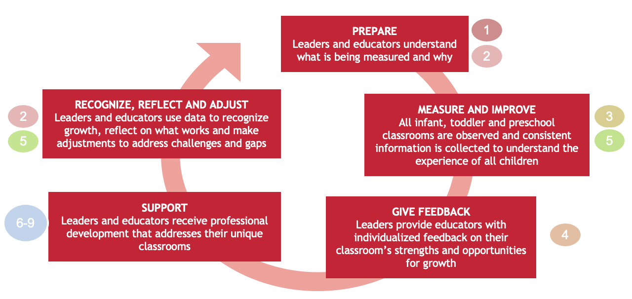

As programs’ most pressing needs are likely to evolve over time, site leaders are encouraged to return to the Toolkit as their program progresses through steps of the cycle!

Section 1) How can I understand or help my teachers understand the CLASS® tool(s)?

- Tip: This is a great topic to start with as you focus on the PREPARE step of the improvement cycle and if you or your teachers have questions like: How can I prepare for my CLASS® observation? What is “CLASS®?” What do quality teacher-child interactions look like (with different ages/ /populations/settings)? What are the CLASS® Infant, Toddler, and PreK tools?
- CLASS® Tool Summaries  (1-page handouts that describe dimensions and give examples of what they look like in the classroom)  English: Infant / Toddler / PreK / Birth-to-five Alignment  Spanish: Infant / Toddler / PreK / Birth-to-five Alignment  - CLASS® Dimensions Guides  (more extensive guides with dimension descriptions and examples and tips to grow interactions) → VQB5 PDG participants are eligible for a free copy during the practice years or purchase from Teachstone.  - Introduction to CLASS® Trainings  (in-person, remote synchronous or asynchronous sessions) → check with your VQB5 Regional Lead Agency for available free trainings or purchase training(s) from Teachstone  - Resources for using CLASS® with diverse populations and settings:  Early Childhood Special Education  (downloadable/printable booklet that highlights use of CLASS® in inclusive classrooms with children who are receiving special education services)  Dual Language Learners  (webpage with resource links to explore to support DLLs and the teacher who serve them)  CLASS® Spanish Suite - Teachstone  (webpage with resource links to explore showcases offerings of Spanish-language responses for coaches, observers, and leaders as well)  Family Day Home/Family Child Care Resources - Teachstone  (webpage with resource links to explore including webinars & video exemplars that support Family Day Home providers in promoting effective interactions)  How to Provide High Quality Family Child Care (NAEYC Webinar)  (Discusses how in Family Day Home or Child Care providers can offer the highest quality early care and education to children ages birth to eight related to CLASS® Domains – Time-stamped: 20:35 – 39:07) | Recommended for:  - Teachers and Leaders: All levels

Section 2) How can I self-assess strengths and areas for growth related to interactions?

- Tip: This section aligns with both the PREPARE and RECOGNIZE, REFLECT, AND ADJUST steps of the improvement cycle. It can help prepare teachers or leaders for CLASS® observations and support reflection on interactions before or between CLASS® observations, or before and after engaging in improvement (SUPPORT) efforts.
- Teacher-Child Interactions Self-Assessments  (1- to 2-page downloadable/printable documents to help teachers self-reflect on their interactions with children)  English: Infant / Toddler / PreK  Spanish: Infant / Toddler / PreK  - Program CLASS® Self-Studies for Leaders  (4- to 7-page downloadable/printable PDFs to help leaders reflect on and informally observe interactions)  English: Infant / Toddler / PreK  Spanish: Infant / Toddler / PreK | Recommended for:  - Teachers including Family Day Home Providers: All levels  - Leaders including Family Day Home Providers: All levels

Section 3) How can I collect local CLASS® data and ensure consistency of that data?

- Tip: This section supports the MEASURE AND IMPROVE step of the improvement cycle.
Collecting local CLASS® data:  - Local Observation Guidebook  VDOE protocols and tips for planning and collecting local CLASS® data (printable/downloadable guide)  - CLASS® Manuals (Infant, Toddler, and PreK) with protocols for observation can be purchased through Teachstone, as part of the CLASS® Observation Training.  (detailed manuals for certified observers to use as they conduct observations)  Ensuring consistency of data:  - Resource Guide for CLASS® Observer Support  (word document with embedded resource links to explore, copied below):  - Consult Teachstone’s Reliability Support page  (webpage with resource links to explore)  - Observer Tip sheets:  Infant coding (downloadable/printable PDF document)  Toddler coding (downloadable/printable PDF document)  PreK coding (Spanish) (downloadable/printable PDF document)  Family Day Home coding (short blog post)  - Consider purchasing individual or group calibration from Teachstone (webpage with links to purchase) | Recommended for:  - Leaders and Local observers: Intermediate to Advanced

Section 4) How can I give effective CLASS® feedback to teachers?

- Tip: This section aligns with the GIVE FEEDBACK step of the improvement cycle and resources below can help leaders prepare to give feedback to teachers that both affirms current efforts and helps them take specific steps towards improvement.

- Providing Feedback on CLASS®  Quickstart Guide  (downloadable/printable PDF resource with steps, tips, and tools)  Principles of Effective Feedback  (downloadable/printable PDF document with guiding principles)  - Giving Effective Feedback Mini-Module  Module Link / Module Handout  (20-minute video recording and accompanying handout with embedded links) | Recommended for:  - Leaders and coaches who are feedback providers or who support feedback providers: All levels

Section 5) How can I understand and use my local CLASS® data to identify areas for improvement?

- Tip: This section aligns with the MEASURE AND IMPROVE and RECOGNIZE, REFLECT, AND ADJUST steps of the improvement cycle. These resources can help leaders access and use their data to recognize the quality of interactions and reflect on how they might build on strengths and address areas of need (over time).
This handout on Accessing, Understanding, and Using CLASS® data has all resources below linked on one page.  - Watch Step 1: Accessing Data Reports in Link B5  (2-minute video tutorial)  - Watch Step 2: Understanding Your CLASS® Export Report  (10-minute video tutorial)  - Watch Step 3: Using CLASS® Data  (10-minute video tutorial)  And complete the Using CLASS® Data worksheet(s) that fits your program’s CLASS® data: Infant / Toddler / PreK  (downloadable/printable 2- page worksheets)  If you would like a point of comparison for your data patterns, see these slides with published, publicly available CLASS® data averages  - Tip: Once you understand your CLASS® data well, consider looking at that alongside other classroom data and child data to help guide improvement. See crosswalk of CLASS® to the ICP observation tool in Section 8 and crosswalk to the TPOT observation tool in Section 9. | Recommended for:  - Leaders: All levels
Section 6) How do I provide teachers professional development to strengthen specific needs with interactions (specific domains, dimensions)?

- Tip: These resources help leaders engage in the SUPPORT step of improvement cycle and can be used in any Professional Development format, such as group trainings, Learning Community meetings, 1:1 coaching or mentoring, or teacher self-study.
- ECLKC (Head Start) 15-minute Inservice Suites (primarily PreK focused)  (~15-minute training modules with videos and handouts for teachers and leaders aligned to CLASS® PreK dimensions.)  - Tip: Use the downloadable PDF Crosswalk of 15-Minute In-service Suites with the CLASS® to pick suites that align to a dimension you want to grow.  - Virginia’s Infant Toddler Specialist Network website  (website that provides access to recorded webinars, downloadable handouts, virtual training offerings, and form to request on-site training and support).  - Sample ITSN handout: Positive Interactions: Helping Toddlers Succeed (downloadable PDF with tips for positive interactions including behavioral guidance with toddlers).  - Child Care Aware of Virginia website  (website that provides access to free in-person and virtual training offerings, including training on trauma-responsive care and the Endorsement (CDA) Program).  - Infant/Toddler Resource Guide: Engaging in Meaningful Interactions (Head Start Child Care)  (printable/downloadable 2-page PDF handout with tips & resources for responsive interactions with infants and toddlers)  - Child Care Videos: Infant/Toddler Care Learning Suite (Head Start Child Care Technical Assistance Network)  (website with links to multiple video clips of high-quality interactions in child- care and Family Day Home settings, with accompanying reflection questions for teachers; e.g., see “Dirt and Grass”; “Baby Talk”)  - Learning Community Guidance for Supporting Interactions (Virginia Quality)  (printable/downloadable 2-page PDF that provides an outline for learning community sessions/meetings related to CLASS®)  - Family Child Care Environments (NAFCC Video):  (Exploring how child-care providers can take a whole-child approach when  designing their child-care curriculum or organizing their space focusing on  teacher-child interactions.(CLASS® Time-Stamped: 7:26-11:57; 15:17-20:57)  *Note: Teachstone offers CLASS®-focused PD for a fee (e.g. Foundations for Teachers online course, other Teacher PD options). (webpage with links to purchase) à Talk to your Ready Regions/Community Lead or Quality Improvement Provider to learn more. | Recommended for:  - Leaders: All levels

Section 7) How do I provide teachers professional development to strengthen interactions through effective implementation of curricula?

- Tip: These resources help leaders engage in the SUPPORT step of improvement cycle and can be used in any Professional Development format, such as group trainings, Learning Community meetings, 1:1 coaching or mentoring, or teacher self-study.
Programs can strengthen interactions through effective implementation of curricula. How can PD support this?  - VDOE recommends that teachers and leaders first engage in foundational professional development (PD) for their curricula. Usually this is provided by a curriculum publisher or developer.  - After foundational PD is provided, leaders can pair a focus on curriculum and interactions. Using a Curriculum-CLASS® crosswalk, when available for your chosen curriculum, helps teachers see how implementing the curriculum aligns with interactions (especially dimensions of need). See below for examples of downloadable/printable curriculum-CLASS® crosswalks (found online as of 3/31/22).*  - Connect for Learning (PreK)  - Creative Curriculum (PreK)  - Frog Street (PreK)  - HighScope Assessment (PQ) (Infant & Toddler)  - STREAMin3 (PreK, Infant & Toddler)  - Tools of the Mind (PreK)  *Note that crosswalks to other curricula may also exist! If your curriculum is not listed above, consider contacting your curriculum publisher to inquire if there is one available for your curriculum. | Recommended for:  - Leaders: All levels

Section 8) How do I provide teachers professional development to strengthen interactions, inclusive practices, and ensure individualized supports for each and every learner?

- Tip: These resources help leaders engage in the SUPPORT step of improvement cycle and can be used in any Professional Development format, such as group trainings, Learning Community meetings, 1:1 coaching or mentoring, or teacher self-study.
- ECE Resource Hub  (website with PD videos, guides, and instructional resources; embeds diversity, equity & inclusion topics organized by children’s skills (e.g., social-emotional))  - Tip: Check out this downloadable/printable PDF ECE Resource Hub: Guide for Leaders Planning Professional Development to learn more about what’s available on the Hub and how you can plan effective group PD using these resources  - Videos: Why Inclusion is Important? (The STEMIE Center)  - Part 1: Let’s Change Attitudes and Beliefs (2-minute video)  - Part 2: Key Characteristics of High-Quality Inclusive Education (5-minute video)  - Part 3: Social Outcomes in Inclusion (2-minute video)  - VA Inclusion (LEADS)  (website with many linked resources specifically related to Inclusion in Early Childhood in the Commonwealth of Virginia)  - Inclusive Placement Opportunities for Preschoolers (IPOP) Manual (website with brief description and link to access extensive manual with embedded multi-media resources). The IPOP manual accompanies long-term technical assistance to support systems change for improving the quantity and quality of inclusion for preschool children with disabilities à Contact your regional TTAC for more information here.  - Head Start Inclusion (ECLKC)  (website with training modules, tip sheets, and tools including instructional  videos to explore).  - ECLKC (Head Start) 15-Minute Inservice Suites on Highly Individualized Teaching and Learning (PreK focused)  (webpage with links to a series of training modules with videos and handouts for teachers and leaders)  - Understanding Inclusion Series (Early Choices)  (webpage with links to a variety of quick videos with embedded resources and activities to help understand, promote, and advocate for inclusion)  - Inclusive Classroom Profile (ICP) Crosswalks with CLASS® (Crosswalk: ICP and CLASS®-PreK and Crosswalk: ICP and CLASS®-Toddler). Using these downloadable/printable PDF/docs can help coaches, leaders, and/or teachers see how implementing inclusive practices aligns with interactions (especially dimensions of need). | Recommended for:  - Leaders and coaches: All levels

Section 9) How do I provide teachers coaching to strengthen interactions, inclusive practices, and ensure individualized supports for each and every learner?

- Tips: These resources help leaders engage in the SUPPORT step of improvement cycle. The resources below address ways to support teachers through coaching. See Sections 1, 2, 6, 7 and 8 for professional development resources to use within coaching (e.g., Teacher Self-Assessments, videos, and handouts aligned to a teacher’s coaching goals).
- Practice-Based Coaching (Head Start)  (website with resources for using a coaching approach that follows a cyclical process)  - Supporting High-Quality Interactions TA Guide (Virginia Quality) (downloadable/printable PDF handout that details multiple types of Technical Assistance (TA) approaches that support the classroom and program improvement, including coaching)  - Teachstone CLASS® Coaching Resources  (webpage with links to a variety of tools and resources for implementing  coaching, including virtually)  - National Center for Pyramid Model Innovations (NCPMI)  (website that outlines the Pyramid Framework to promote children’s social-emotional learning, including emotionally supportive interactions and a focus on equity, with links to embedded printable/downloadable handouts)  - See also Teaching Pyramid Observation Tool (TPOT, for PreK). Crosswalk: TPOT and CLASS®-PreK.  Using this downloadable/printable PDF can help coaches, leaders, and/or teachers see how implementing Teaching Pyramid practices aligns with interactions (especially dimensions of need). | Recommended for:  - Coaches and leaders who coach teachers or support coaches: All levels

